26th September 2019

**Stefano Artuso takes Yokohama to victory in the GT Cup Trophy of the Italian Championship “Velocità Montagna 2019”**

The Driver from Padova, leader of the Scuderia Superchallenge Team, concluded a brilliant race that made him the best in the GT Cup class with a total of 122.5 points. Artuso is the first winner of the GT Cup Trophy, which has been established by the committee of the Campionato Italiano Velocità Montagna this year.

Artuso’s success was due to the combination of great driving skills and the “feeling” with the Yokohama A005 ADVAN tyres, that he equipped in all the races, starting with technical races such as the Sarnano-Sassottetto and the Rieti-Teminillo, to the classic ones like the legendary Trento-Bondone, the Verzegnis-Sella Chianzutan and, the more recent Monte Erice. Every race had different features in setup and also different types of tarmac where Yokohama tyres always provided the Ferrari 458 Challenge an outstanding grip.

A delighted Giuseppe Pezzaioli - Yokohama Italia Motorsports Manager was full of praise for the driver in such a significant victory whilst at the same time, confirming the high performance and premium quality of the Japanese tyres. We really are excited about this result and with the cooperation with Stefano Artuso. Advan A005 are slick tyres made specifically for GT cars, one of our most successful products. These races, if compared to the track competition, require a great performance from the tyres: the tracks are very short, rarely more than 10 km, where the tyre has to warm up quickly and maintain an even grip from the first till the last metre. In these races you have to face all types of tarmac issues, that really put the tyres to the test, but with this result we confirmed once again the great sport value of our product”.

For his part, Stefano Artuso expressed satisfaction at obtaining such results on the first season with a great car like the Ferrari 458 Challenge fitted with Yokohama tyres. He mentioned it was not the first time he has raced with the tyres and this year he was really impressed by the feeling they gave him on all the different types of tarmac. “They get to the right temperature quickly and they perform at their best. This allowed me to express the full potential of car and to be in more than one occasion faster than the more powerful Super GT Cup cars. He added.

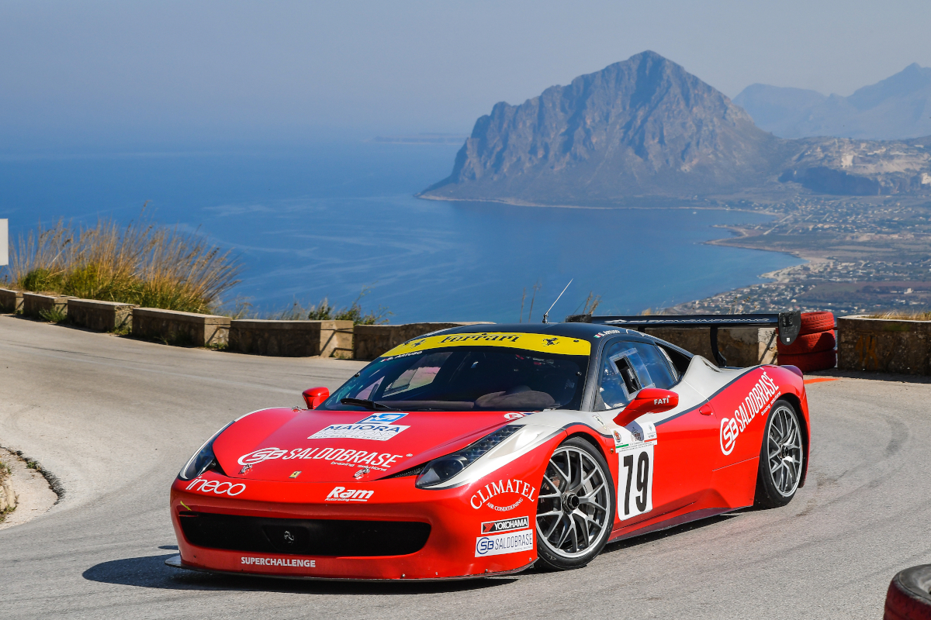

*GPR_1933*